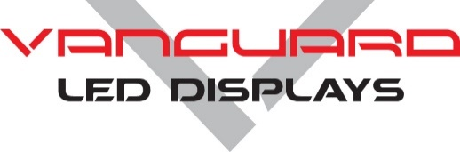**Product** **Specifications**

**RHODIUM SERIES**

**Indoor P2.5 • 16:9 aspect ratio LED Display**



**Overview**

Vanguard’s Rhodium Series has a 16:9 native aspect ratio of 16:9. If cabinets are arrayed with equal cabinet height & width (i.e. 10x10 or 8x8), the entire display will retain a 16:9 viewing aspect ratio. Rhodium is available in pixel pitches of P2.5 and P4.

Rhodium can be serviced from either the front **or** rear of the cabinet. Cabinets can utilize external jumpers from cabinet to cabinet. Alternatively, the cabinets may be internally cabled in order to achieve a flat back, allowing for wall mounting. Rhodium cabinets can be wall mounted, flown or ground stacked. Quick Locks provide easy installation. Pre-threaded mounting location make installation simple. Magnetic LED modules make module replacement quick & easy.

**Additional Features**

* Fan-less design.
* Low Power Consumption.
* Designed for maximum heat dissipation.
* Pixel to Pixel color calibration for brightness and color uniformity.
* Seam brightness compensation is standard.
* High gray scale & high refresh rate.
* Flicker fee for broadcast applications.
* Black LED’s for high contrast ratios and sharp image quality.
* Low profile mask offers very wide viewing angles.
* 16-bit color processing technology.
* Superb color & brightness uniformity.

**Rhodium Technical Specifications**

Rhodium Indoor P2.5

CABINET

Cabinet Material Die Cast Aluminum

Cabinet Size 25.2” x 14.7”

Cabinet Resolution 256 x 144

Modules Per Cabinet 4

Cabinet Weight 19.1lbs.

Service Access Front or Rear

IP Rating IP31

EXTERNAL CONNECTIONS

Data in / out RJ45

AC Power in / out PowerCon

ENVIRONMENTAL

Operating Temperature -10°C to +50°C

Storage Temperature -20°C to +60°C

Operating Humidity 20% to 90% RH

AC POWER

Source Voltage 100-240V, 50/60Hz

Max Power Consumption 104W

Avg. Power Consumption 55W

INTERNAL OPERATION

Driving Method 1/18th Scanning

Gray Scale 14-16bit

IC Driver MB15153

Refresh Rate 3840Hz

Frame Frequency 60Hz

LED

LED Type SMD1R1G1B

LED Configuration 3 in one

Pixel Density 160,000/m²

Module Size 12.6” x 7.35”

Module Resolution 128 x 72

Modules Per Cabinet 4

Lifetime to Half Brightness (L50) 100,000

Contrast Ratio >2,000:1

Brightness 800Nits

Viewing Angle 140° x 140°

Minimum Viewing Distance 8.3 ft.

ACCESSORIES

Single / double cabinet fly bar

Single / double cabinet ground stack bar

**Rhodium Technical Specifications**

