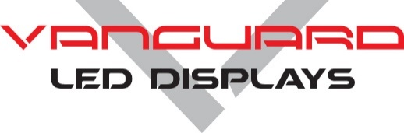**Product** **Specifications**

**RHODIUM SERIES**

**Indoor P4 • 16:9 aspect ratio LED Display**



**Overview**

Vanguard’s Rhodium Series has a 16:9 native aspect ratio. If cabinets are arrayed with equal cabinet height & width (i.e. 10x10 or 8x8), the entire display will retain a 16:9 viewing aspect ratio. Rhodium is available in pixel pitches of P2.5 and P4.

Rhodium can be serviced from either the front **or** rear of the cabinet. Cabinets can utilize external jumpers from cabinet to cabinet. Alternatively, the cabinets may be completely internally cabled in order to achieve a flat back for wall installations. Rhodium cabinets can be wall mounted, flown or ground stacked. Quick Locks provide easy installation. Pre-threaded mounting location make installation simple. Magnetic LED modules make module replacement quick & easy.

**Additional Features**

* Fan-less design.
* Low Power Consumption.
* Designed for maximum heat dissipation.
* Pixel to Pixel color calibration for brightness and color uniformity.
* Seam brightness compensation is standard.
* High gray scale & high refresh rate.
* Flicker fee for broadcast applications.
* Black LED’s for high contrast ratios and sharp image quality.
* Low profile mask offers very wide viewing angles.
* 16-bit color processing technology.
* Superb color & brightness uniformity.

**Rhodium Technical Specifications**

Rhodium Indoor P4

CABINET

Cabinet Material Die Cast Aluminum

Cabinet Size 25.2” x 14.7”

Cabinet Resolution 160 x 90

Modules Per Cabinet 4

Cabinet Weight 19.1lbs.

Service Access Front or Rear

IP Rating IP31

EXTERNAL CONNECTIONS

Data in / out RJ45

AC Power in / out PowerCon

ENVIRONMENTAL

Operating Temperature -10°C to +50°C

Storage Temperature -20°C to +60°C

Operating Humidity 20% to 90% RH

AC POWER

Source Voltage 100-240V, 50/60Hz

Max Power Consumption 200W

Avg. Power Consumption 100W

INTERNAL OPERATION

Driving Method 1/15th Scanning

Gray Scale 14 – 18 bit

IC Driver MB15153

Refresh Rate >3840Hz

Frame Frequency 60Hz

LED

LED Type SMD2121 Black

LED Configuration 3 in one

Pixel Density 62,600/m²

Module Size 12.6” x 7.35”

Module Resolution 80x45

Modules Per Cabinet 4

Lifetime to Half Brightness (L50) 100,000

Contrast Ratio 2,000:1

Brightness 800Nits

Viewing Angle 140° x 140°

Minimum Viewing Distance 13.2 ft.

**Rhodium Technical Specifications**